INSTRUCTION MANUAL FOR VORTEX MIXER VM-2000 & VM-2000-C
Head
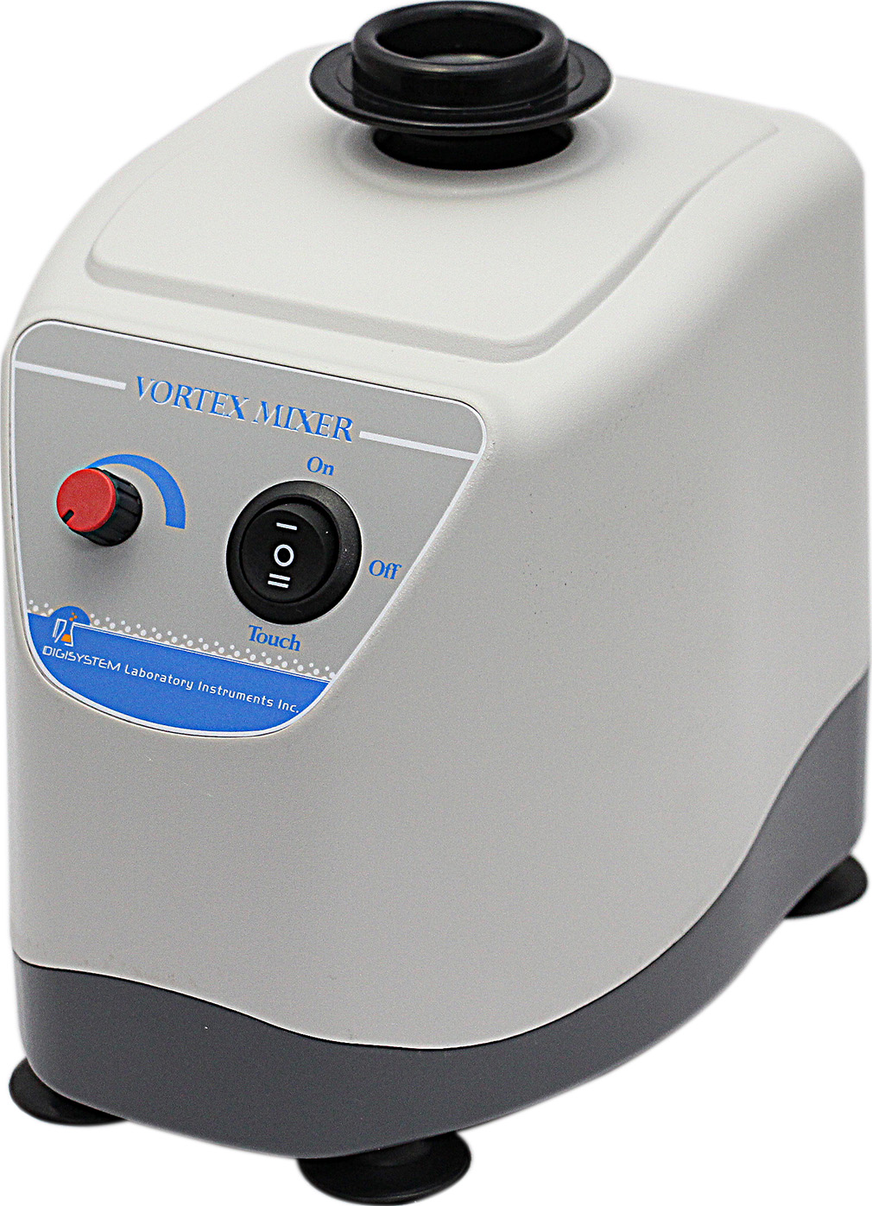
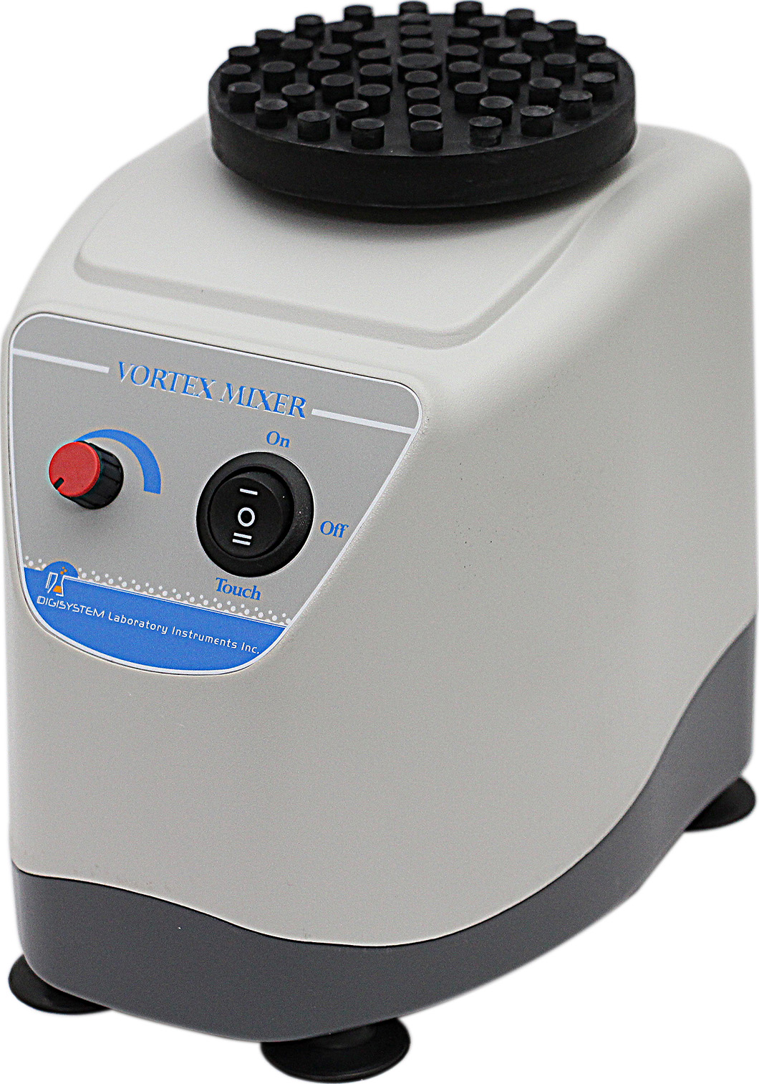

Speed controller
Switch
(AUTO/OFF/TOUCH)

VM-2000-C VM-2000
Warnings:
* Do not remove the mixer during operation.
* Place the mixer securely away from the edge of bench to avoid the mixer falling off the bench top.
* Do not disassemble the mixer by yourself. In the event of a malfunction, the mixer should be repaired by a qualified technician. Before repairing, turn off the power.
* Clean up the head once the user finds any liquid on the head, otherwise the head will get damaged easily.
Steps:
- Place the mixer on a flat and stable bench top. Plug the mixer into a properly grounded outlet which corresponds with the electrical requirements on the label back on machine.
- Place the ‘Switch’ at ‘TOUCH’ position. The unit will run as soon as touch on the ‘Head’. The ‘Power indicator’ lights.
- Place the ‘Switch’ at the ‘AUTO’ position, the unit will run automatically.
- Turn the ‘Speed controller’ to the required speed.
Warning: Do not make the motor race rotation to avoid damage. After finishing operation, please place the switch at ‘TOUCH’ or ‘OFF’ position.

Maintenance and care:
Keep the machine clean all the time, so no routine maintenance is required. Cleaning can be done with a damp cloth. Avoid the use of solvents as they may damage the machine housing.

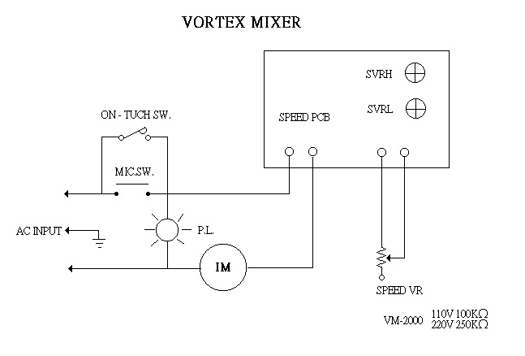
Circuit Diagram

Service Manual
Troubleshooting Guide
Caution: Always disconnect the power cord before troubleshooting.
Trouble | Cause | Remedy
Instrument inoperative | Power cord not connected to outlet. | Plug in the power cord.
Instrument inoperative | Dead power output. | Change to different output.
Instrument inoperative | Defective electronic component. | Contact your distributor for repair.
Head doesn’t rotate | Switch isn’t at ‘AUTO or “TOUCH’ position. | Place the switch at ‘AUTO or “TOUCH’ position.
Head doesn’t rotate | Eccentric brass rod doesn’t work well. | Contact your distributor for repair.
Head doesn’t rotate | Switch is broken. | Contact your distributor for repair.
Head doesn’t rotate | Motor is broken. | Contact your distributor for repair.
Head doesn’t rotate | PC board is broken. | Contact your distributor for repair.
Speed can’t not be controlled | PC board is broken. | Contact your distributor for repair.
Speed can’t not be controlled | Speed controller is broken. | Contact your distributor for repair.
There is a big noise during operation | Eccentric brass rod doesn’t work well. | Contact your distributor for repair.
There is a big noise during operation | Belt which is to fix the eccentric brass rod doesn’t work well. | Contact your distributor for repair.
The “TOUCH” function can’t work | Switch isn’t at “TOUCH’ position. | Place the Switch at ‘TOUCH’ position.
The “TOUCH” function can’t work | The starting button under the motor is broken. | Contact your distributor for repair.

